COUPLED TANDEM PACKING DIRECTIONS

GENERAL
Disk wheels – check disk is between pads.
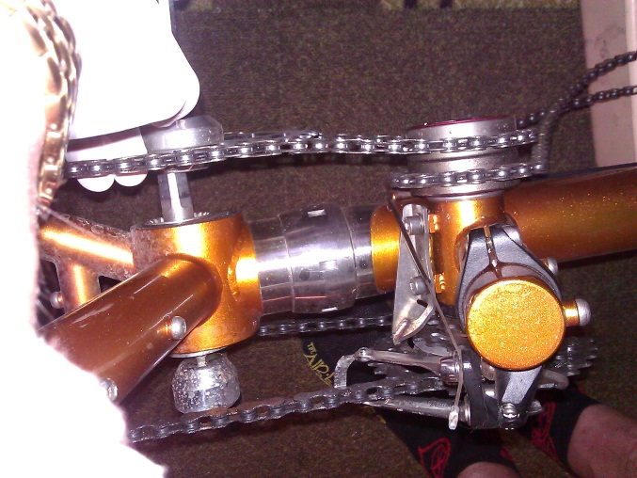
**Note placement clues to align tubes.
DISASSEMBLY / REVERSE TO ASSEMBLE
Cages, computer, pump, pedals, saddle bags, rack
Seat tubes (w/ saddles on)
Adjustable stoker stem (separate @ center stem)

Remove captain and stoker left foot cranks (6mm ?)
Timing chains comes off; zip tie on flat surface
ID captains’ and ID stokers

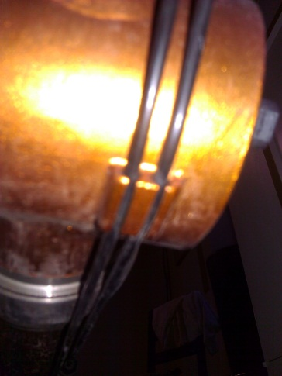
Screw apart cables (FD, RD, RB, RB)
Rear brake cable stays on INSIDE;
Rear derailleur cable on the RIGHT (facing front)
Cables never cross
Separate cables from the cable guides
Move cable cover to slip cable into guides and then slide cover)
LOOSEN S&S couplers (custom coupler wrench)

Vertical bolt on headset OFF
Horizontal bolts (2) on headset loosen
Handle bar off but remains attached to fork with brake cable

Remove fork
Replace spacers on fork steerer tube in EXACT order
and secure with vertical bolt
Wheels – skewers come out OFF
Insert supports into rear drop-outs and the fork

Unscrew couplers …separate tube sections**

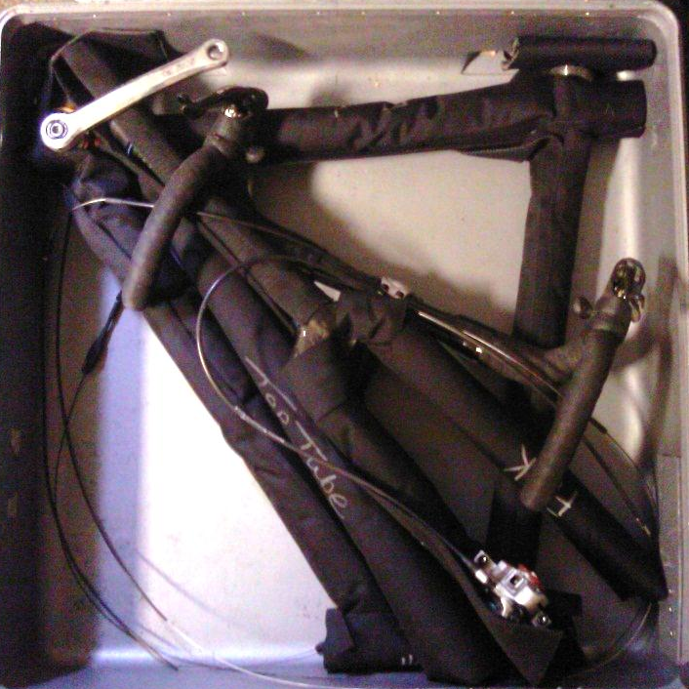
BOXING / PACKING

Wrap up tubing (each tube wrap is labeled)
Zip tie RD to chain stay
BOX 1 contains:
Front triangle,
Fork blade along ∆
Stoker (rear) top tube (along diagonal of ∆ down tube)
Front wheel (disk IN)
Captain saddle
Captain handle bars (upside down with stem under)
Captain crank
1 pair shoes
1 helmet
Hydration pack
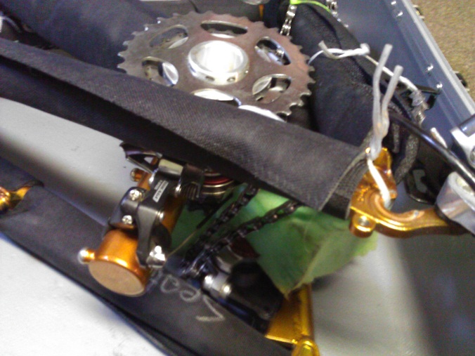
BOX 2 contains:
Rear ∆ with support between drop outs
Keel (aka boom) tube
Chain rings brought near derailleur
And “twist” tied together
Stoker saddle
Stoker handle bars
Rear wheel (disk IN, cassette protected & OUT)
1 pair shoes
1 helmets
Water bottle

TOOLS
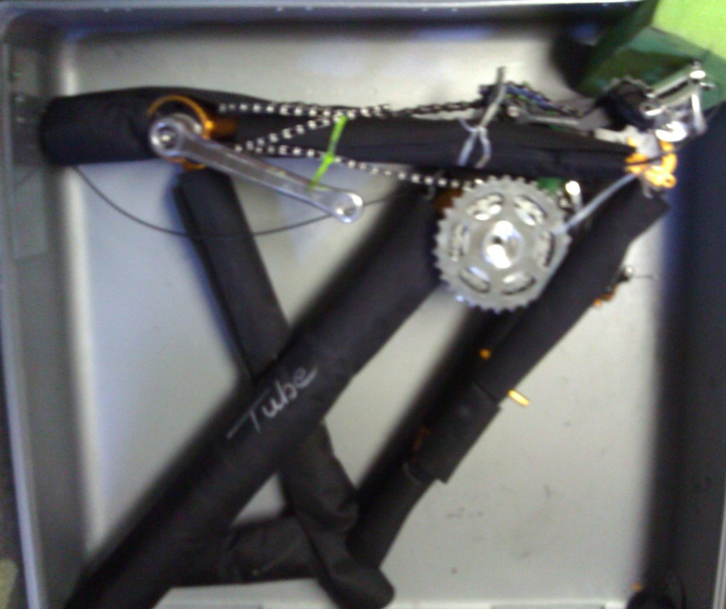
Pedal wrench ?
Coupler wrench (pedal wrench on coupler tool)
4, 5, 6, mm allen wrenches
Zip ties, scissors

